PHENOLICS
Phenolic compounds are characterized by the presence of at least of the aromatic ring substituted by at least one hydroxylic group, and their derivatives.
Phenols and phenolic glycosides of different types are widespread in nature and are to be found in the most classes of natural compounds having aromatic units, such as simple phenolic compounds, tannins and lignins, coumarins and chromones, xanthones, quinones, flavonoids.
As their name suggests, most of these compounds contain in their structure a phenyl ring attached to a three-carbon propane side chain, and in contradistinction to the alkaloids, cyanogenic glycosides, and glucosinolates, they are devoid of nitrogen.
The principal precursors for phenylpropanoid compounds are cinnamic acid and p-hydroxycinnamic acid, also known as p-coumaric acid. In plants, these compounds arise from the aromatic amino acids phenylalanine and tyrosine, respectively, which in turn are synthesized via the shikimic acid pathway.
Therefore, plant phenolics are compounds devoided of nitrogen, whose aromatic ring(s) arose chiefly from the metabolism of shikimic acid, or that of polyacetate, or both.

Classification of phenolics
Approaches to classification of plant phenolics are based on
a) a number of hydroxylic groups. According to that they may be divided on 1-, 2- and polyatomic phenols. Phenolic compounds containing more than one OH-group in aromatic ring are polyphenols.
b) chemical composition: mono-, di, oligo- and polymers.
c) substitutes in carbon skeleton, a number of aromatic rings and carbon atoms in the side chain.
According to the latter principle, phenolic compounds are divided into four main groups: phenolics with one aromatic ring, with two aromatic rings, quinones and polymers.

Phenolic compounds with one aromatic ring.
A large number of compounds, among them are simple phenols (C6), phenol with attached one (C6-C1), two (C6-C2) and three (C6-C3) carbon atoms.
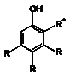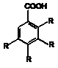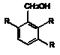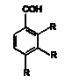
simple phenols (C6), phenolic acids, alcohols, aldehydes (C6-C1).
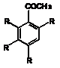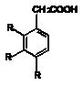
acetophenones, phenylacetic acids (C6-C2)
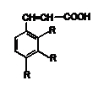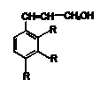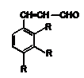
hydroxycimmamic acids, alcohols, aldehydes (C6-C3)

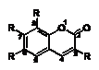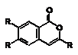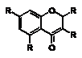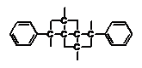

coumarins, isocoumarins, chromones (C6-C3) lignans (dimers), (C6-C3)2

Phenolic compounds with two aromatic rings.
This group includes benzoquinones and xanthones (C6-C1-C6) containing two aromatic rings which are linked by one carbon atom; stylbenes (C6-C2-C6) which are linked by two carbon atoms; and flavonoids, containing three carbon atoms (C6-C3-C6). Flavonoids, depending on the structure of propane unit and an attaching place of side chain B, are divided into flavonoids in strict sense, which are derived from chromane or chromone, isoflavonoids and neoflavonoids.
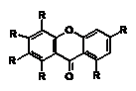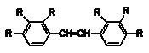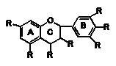
xanthones (C6-C1-C6) stylbenes (C6-C2-C6) flavonoids (C6-C3-C6)

Main groups of quinones are benzoquinones (C6), naphtoquinones (C10) and anthraquinones (C14).
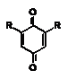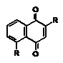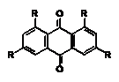
benzoquinones (C6) naphtoquinones (C10) anthraquinones(C14)

Polymeric phenolic compounds include tannins (condensed and hydrolized) and lignans (C6-C3)n.

Physical and chemical properties of phenolic compounds
In general, phenols are soluble in polar organic solvents; they are soluble in sodium hydroxide and carbonate solutions. Bicarbonates solubilize phenolic acids; they can be extracted with organic solvents in slightly acidic conditions. The glycosides of these phenolic compounds are, classically, soluble in water.
All of these compounds are unstable. All phenols are readily oxidized, especially in alkaline conditions. The analysis of simple phenolic compounds from a plant is commonly carried out by TLC, or by GC (following silylation), HPLC, or both. The TLC solvents are mixtures that contain an acid most of the time (acetic, formic) and the TLC plates are coated with cellulose or silica gel or a mixture of the two. The spots are visualized using general reagents for phenols (ferric chloride, vanillin and hydrochloric acid in alkaline conditions) or using more specific reagents (e.g., 2,4-dinitrophenylhydrazine for aldehydes). The analytical method of choice is HPLC. In general it is carried out on reverse phases and eluted with mixtures of water, alcohols (or acetonitrile or both) and acids (to limit ionization).

Extraction & Separation
These compounds are generally extracted, preferably from fresh plant material, with an alcohol, or alternatively, to extract less lipophilic substances and avoid partial esterification of the phenolic acids, with an alcohol and water mixture. Considering the fragility of these molecules, it is best to work in an inert atmosphere, to avoid extreme pHs, and to concentrate the extracts at low temperature (30°C). Back extraction of the aqueous solution with nonmiscible solvents of increasing polarity separates compounds in the free state, esters, and glycosides.
Separation of the constituents of mixtures can be achieved by classic chromatographic techniques on polyamide, cellulose, silica gel, or, in the case of phenylpropanoic esters, on gels and on ion exchange resins.

Detection of Phenolic compounds
In medicinal plant materials simple phenolic glycoside arbutin may be identified by reaction with ferric sulphate. Reddish-violet, later dark violet colour develops and precipitates. Arbutin with ammonia and phosphor molibdate sodium at the hydrochloric acid medium produces blue colour. Hydrolized tannins in arbutin yielding MPM are identified by reaction with ferric alum, developing dark blue colour.
Quantitative determination of arbutin is carried out by iodometric method. To lead acetate is added sulphuric acid and zinc, later sodium hydrocarbonate to neutralize medium. Iodine solution is added to the titrate until blue colour is developed, starch is an indicator. EuPh describes spectrophotometric determination of arbutin in Folia Uvae ursi after TLC.

Simple Phenols (C6)
The group includes phenol and its derivatives, having no side carbon chains. Depending of a number of OH-groups simple phenols are divided into monohydroxyphenols (phenol), dihydroxyphenols (cathehol, pirocatechine (cathechol), resorcine, hydroquinone) and trihydroxyphenols (phloroglucinol, pyrogallole, hydroxyquinone).
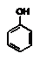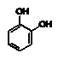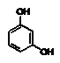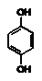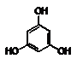

phenol pyrocatechine resorcine hydroquinone phloroglucine

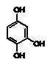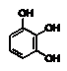
hydroxyhydroquinone pyrogallole

The phenolic compounds of this group also often possess alcoholic, aldehydic and carboxylic acid groups. Phenolic glycosides are widely spread in Ericaceae, Rosaceae, Saxifragaceae, Tiliaceae, Vacciniaceae, Salicaceae.
Simple phenols seldom occur naturally, except for hydroquinone which is found in several families (including Ericaceae and Rosaceae ), most often as the glucoside of the diphenol (arbutin) or of its monomethyl ether. Hydroquinone and methylhydroquinone are found in free state and glycosidic form (arbutin, methylarbutin). Arbutin is widely used in medicine as potent natural urinary antiseptic.
Phloroglucine derivatives (aspidinol as well) are found in Rhizomata Filicis maris and are the precursors of humulic acid in hops of Humulus lupulus.

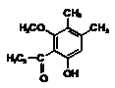
aspidinol

Phenol derivatives are the main constituents of volatile oils, i.e. thymol (2-isopropyl-5-methylphenol) and its isomere carvacrol, yielding in volatile oil of Thymus spp. and Origanum vulgare. Pyrocatechine is found in leaves of Thea sinensis. Pyrogallole is component of tannin structure; it is also used in dermatology.

Phenolic alcohols and phenolic aldehyde
Phenolic alcohols (C6-C1) have alcoholic group and may be differentiated by a number of phenolic hydroxylic groups that may be free or methylated. These compounds are rare in high plants; among them the most abundant are salicylic, hentisinic, coniferylic and sinapic alcohols. Salicylic alcohol (saligenin) is an aglycone of salicin, found in a bark of Salix spp., possessing anti-inflammatory action. Coniferylic alcohol plays an important role as biological precursor of lignin. Sinapic alcohol (sirenginin) is one of the main compounds involved in biosynthesis of lignin of Angiosperms and is an aglycone of sigengin, yielding in Syringa vulgaris, Oleaceae.

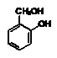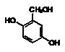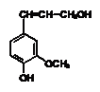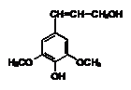
salicylic alcohol gentisinic alcohol coniferylic alcohol sinapic alcohol

The most important phenolic aldehydes are vannilin, piperonal, salicylic and anise aldehydes.
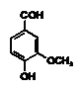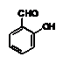
vannilin salicylic aldehydes
Vannilin (3-methoxy-4-hydroxybenzaldehyde) as glycoside is yielding in Vannila planifolia, Orchidaceae. It may be prepared synthetically from eugenole. Vannilin is employed as a flavoring agent. Salicylic aldehyde (0-hydroxybenzaldehyde) is found in volatile oil of Filipendula ulmaria, Rosaceae.

Phenolic glycosides

Simple phenols, phenolic alcohols and aldehydes and their derivatives occur in plants mostly as glycosides with glucose, xylose and arabinose.
Arbutin (β-D-glucopyranoside hydroquinone) upon hydrolysis yields hydroquinone and glucose. Its content in plants varies from 0.5% to 20%. The most important arbutin containing plants are Arctostaphyllos uva ursi, Vaccinium vitis-idaea, Bergenia crassifolia, Vaccinium myrtillus. Arbutin during excretion exerts an antiseptic action on the urinary tract in alkaline medium. Methylarbutin is often associated with arbutin in plants. It is more difficult to be hydrolized.
Rodioloside, or salidroside (β-D-glucopyranoside n-hydroxyphenilethanol) is derived from rhizomes of Rhodiola rosea, Crassulaceae and possesses adaptogenic and immune system stimulating action.

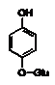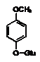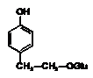
arbutin methylarbutin salidroside

Echinacoside, a glycosidic derivative of 3,4-dioxyphenilethanol, consists of two rhamnose and two residues of glucose, one of which is linked with caffeic acid and is yielding in Echinacea spp. acts on one of mechanisms of immune system, activates phenocytosis.
Here the aglycone is a simple phenolic structure. An example is arbutin found in the Common Bearberry Arctostaphylos uva-ursi. It has a urinary antiseptic effect.

Phenolic acids
The term “phenolic acids” generally describes the phenolic compounds having one carboxylic acid group. Phenolic or phenolcarboxylic acids (a type of phytochemical called a polyphenol) are one of the main classes of plant phenolic compounds. They are found in the variety of plant-based foods viz. seeds, skins of fruits and leaves of vegetables contain them in highest concentrations. Typically, they are present in bound from such as amides, esters, or glycosides and rarely in free form. Phenolic acids are mainly divided in to two sub-groups: hydroxybenzoic and hydroxycinnamic acid. Phenolic acids possess much higher in vitro antioxidant activity than well known antioxidant vitamins. Hydroxycinnamic acids, derived from cinnamic acid, present in foods often as simple esters with quinic acid or glucose. The most abundant soluble bound hydroxycinnamic acid present is chlorogenic acid (a combined from form of caffeic and quinic acids). The four most common hydroxycinnamic acids are ferulic, caffeic, p-coumaric, and sinapic acids. On the other hand, hydroxybenzoic acids possess a common structure of C₆-C₁ and derived from benzoic acid. They are found in soluble form (conjugated with sugars or organic acids) and bound with cell wall fractions as lignin. As compared to hydroxycinnamic acids, hydroxybenzoic acids are generally found in low concentration in red fruits, onions and black radish etc.. The four commonly found hydroxybenzoic acids are p-hydroxybenzoic, protocatechuic, vanillic, and syringic acids.
Phenolic acids are compounds with at least one carboxylic group -COOH and one phenolic OH-group. Phenolic acids, derived from benzoic(C6-C1) and cinnamic(C6-C3) acids, are found in the free state, as depsides and glycosides. Phenolic acids mostly are not main active substances of phytopharmaceuticals, they make the additional healing action of a drug.The most common phenolic acids are prothocathehic, hydroxycathehic, hentisinic and free gallic acid. Vannilic, syringic and n-hydroxybenzoic acids are constituents of lignin. Comparently rare are found salicylic and pirocathehic acids.
Salicylic acid (0-hydroxybenzoic acid) is quite common as methylic ester in some volatile oils and as glycosides. Salicin is a glycoside obtained from several species of Salix and Populus. The glycoside populin (benzoylsalicin) is also associated with salicin in the barks of the Salicaceae. Salicin has antirheumatic and anti-infammatory action. Methylic ester of salicin is an active principle of Herba Violae tricoloris and Flores Ulmariae.
Gallic acid (3,4,5-trihydroxybenzoic) occurs in the free state and as a depside (m-digallic acid). Gallic acid and its dimer (hexahydroxydiphenic acid) are constituents of hydrolyzable tannins. Gallic acid possesses anti-inflammatory, antimicrobical and antiviral action.
Most of C6-C3 phenolic acids, or p-hydroxycinnamic acids (p-coumaric, caffeic, ferulic, sinapic) are very widely distributed. The hydroxycinnamic acids (and their esters) can exist in both Z and E forms, but usually occur naturally as the E form which undergoes isomerization during isolation to yield an equilibrium mixture of both isomers. Coumarins are lactones that are derived from p-hydroxycinnamic acid which undergo ortho hydroxylation then ring closure between the ortho hydroxyl group and the carboxylic group of the side chain, after a trans to cis isomerization of the side-chain double bond.
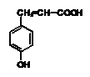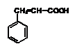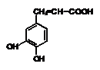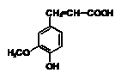
cinnamic p-coumaric caffeic ferulic
acid acid acid acid
Caffeic acid (3,4-dihydroxycinnamic) often forms dimers (depsides). Chlorogenic acid is a pseudodepside of caffeic and quinic acids. Ferulic acid (methylic ester of caffeic acid), spread in Apiaceae, and its esters possess choleretic, antimicrobic and hepatoprotective action.
Quinic and shikimic acid are acyclic acids. Cortex Chinae contains up to 9% of quinic acid. Quinic acid is an important intermediate product of plant constituent biosynthesis, often as the depsides.
Shikimic acid plays an important role in biosynthesis of aromatic aminoacids, cinnamic acids, flavonoids and other phenolic compounds.

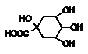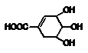

quinic acid shikimic acid

Chicoric acid (2,3-dicoffeilquinic acid), a depside common in Asteraceae, partially causes an action of Echinacea pharmaceuticals.

Phenylpropanoids
The phenylpropanoids are a diverse family of organic compounds that are synthesized by plants from the amino acids phenylalanine and tyrosine.

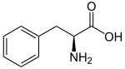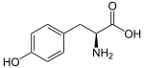

phenylalanine tyrosine

Their name is derived from the six-carbon, aromatic phenyl group and the three-carbon propene tail of coumaric acid, which is the central intermediate in phenylpropanoid biosynthesis. From 4-coumaroyl-CoA emanates the biosynthesis of myriad natural products including lignols (precursors to lignin and lignocellulose), flavonoids, isoflavonoids, coumarins, aurones, stilbenes, catechin, and phenylpropanoids. The coumaroyl component is produced from cinnamic acid.
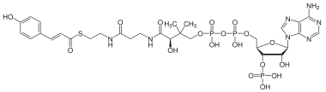
4-Coumaroyl-CoA is the central biosynthetic precursor to phenylpropanoids (shown in protonated state)

Phenylpropanoids are found throughout the plant kingdom, where they serve as essential components of a number of structural polymers, provide protection from ultraviolet light, defend against herbivores and pathogens, and also mediate plant-pollinator interactions as floral pigments and scent compounds.

Hydroxycinnamic acids
Phenylalanine is first converted to cinnamic acid by the action of the enzyme phenylalanine ammonia-lyase (PAL). Some plants, mainly monocotyledonous, use tyrosine to synthesize p-coumaric acid by the action of the bifunctional enzyme Phenylalanine/tyrosine ammonia-lyase (PTAL). A series of enzymatic hydroxylations and methylations leads to coumaric acid, caffeic acid, ferulic acid, 5-hydroxyferulic acid, and sinapic acid. Conversion of these acids to their corresponding esters produces some of the volatile components of herb and flower fragrances, which serve many functions such as attracting pollinators. Ethyl cinnamate is a common example.
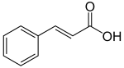
cinnamic acid

Cinnamic aldehydes and monolignols
Reduction of the carboxylic acid functional groups in the cinnamic acids provides the corresponding aldehydes, such as cinnamaldehyde. Further reduction provides monolignols including coumaryl alcohol, coniferyl alcohol, and sinapyl alcohol, which vary only in their degree of methoxylation. The monolignols are monomers that are polymerized to generate various forms of lignin and suberin, which are used as a structural component of plant cell walls.
The phenylpropenes, including eugenol, chavicol, safrole and estragole, are also derived from the monolignols. These compounds are the primary constituents of various essential oils.
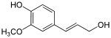
coniferyl alcohol

Coumarins and flavonoids
Hydroxylation of cinnamic acid in the 4-position by trans-cinnamate 4-monooxygenase leads to p-coumaric acid, which can be further modified into hydroxylated derivatives such as umbelliferone. Another use of p-coumaric acid via its thioester with coenzyme A, i.e. 4-coumaroyl-CoA, is the production of chalcones. This is achieved with the addition of 3 malonyl-CoA molecules and their cyclization into a second phenyl group. Chalcones are the precursors of all flavonoids, a diverse class of phytochemicals.
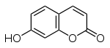 umbelliferone
Stilbenoids
Stilbenoids, such as resveratrol, are hydroxylated derivatives of stilbene. They are formed through an alternative cyclization of cinnamoyl-CoA or 4-coumaroyl-CoA.
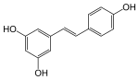 trans-resveratrol

Sporopollenin
Phenylpropanoids and other phenolics are part of the chemical composition of sporopollenin. It is related to cutin and suberin.This ill-defined substance found in pollen is unusually resistant to degradation. Analyses have revealed a mixture of biopolymers, containing mainly hydroxylated fatty acids, phenylpropanoids, phenolics and traces of carotenoids. Tracer experiments have shown that phenylalanine is a major precursor, but other carbon sources also contribute. It is likely that sporopollenin is derived from several precursors that are chemically cross-linked to form a rigid structure.

Phenylethanoid glycosides (PhGs)
Natural products have long been regarded as excellent sources for drug discovery given their structure diversity and wide variety of biological activities. Phenylethanoid glycosides are naturally occurring compounds of plant origin and are structurally characterized with a hydroxyphenylethyl moiety to which a glucopyranose is linked through a glycosidic bond. To date several hundred compounds of this type have been isolated from medicinal plants and further pharmacological studies in vitro or in vivo have shown that these compounds possess a broad array of biological activities including antibacterial, antitumor, antiviral, anti-inflammatory, neuro-protective, antioxidant, hepatoprotective, immunomodulatory, and tyrosinase inhibitory actions. Given their extensive activity profile, structure-activity relationships analyses of these compounds have been performed in a number of studies to reveal potential leads for future drug design.
Phenylethanoid glycosides (PhGs) are a class of water-soluble compounds They have been detected in roots, stems, leaves, flowers, fruits and seeds without organ selectivity, while their concentrations in each organ may vary a lot. As their names suggest, PhGs are characterized by a phenethyl alcohol (C₆-C₂) moiety attached to a β-glucopyranose/β-allopyranose via a glycosidic bond. The core structures are often abundantly decorated with substituents such as aromatic acids (e.g., caffeic acid, coumaric acid, cinnamic acid, ferulic acid, and isoferulic acid) and various saccharides (e.g., rhamnose, xylose, apiose, glucose, lyxose, allose and arabinose) through ester or glycosidic linkages, respectively. Since a 2008 review, more than 100 new PhGs have been isolated and identified. Compared with the known PhGs reported in [4], some of the new ones differed in their core structures, while others differed in the number and/or position of the substituents. The new PhGs with a typical phenethyl alcohol (C₆-C₂) moiety attached to a β-glucopyranose/β-allopyranose

Table 1
The new phenylethanoid glycosides with typical phenethyl alcohol moieties attached to a β-glucopyranose/β-allopyranose.
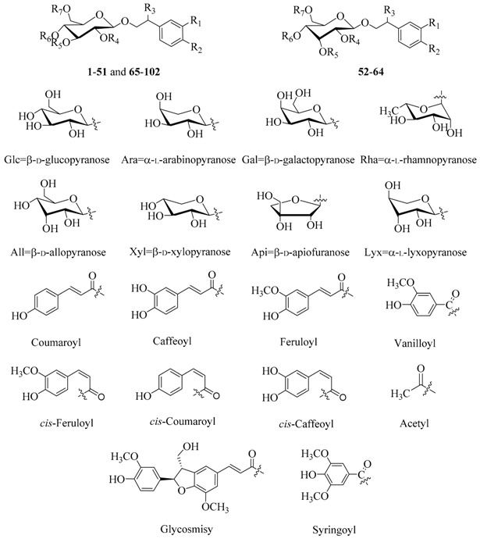

MPM name | Source | Constituents | Action, use
Folia Uvae ursi | Arctostaphylos uva-ursi (L.) Spreng. (bearberry), Ericaceae | arbutin (6-10%) and methylarbutin;  gallotannins (15-20%); flavonoids (quercetin), catechol, ursone, ursulic acid, iridoidstriterpenes, monotropein (an iridoid), picein | diuretic and astringent; as adjunctive therapy in the diuretic treatment of benign urinary disorders, and to enhance the renal excretion of water.
Folia Vitis idaeae | Vaccinium vitis idaea, Ericaceae | arbutin (5-7%), methylarbutin (3%); phenolic and oxycinnamic acids (coffeic, ferulic, chlorogenic); flavonoids; triterpenes; tannins (20%). | antiseptic, diuretic, astringent in kidney stone disease and cystitis.
Rhizomata Filicis maris | Dryopteris filix-mas (L.)Schott. (male fern) , Dryopteridaceae (Aspidiaceae) | phloroglucinol derivatives which occur as mono-, bi-, tri- and tetracyclic compounds; aspidinol, filicinic acid; albaspidin and flavaspidic acid, filicic acid. | antihelmintic.
Strobili Lupuli | Humulus lupulus L.(hops), Cannabaceae | prenylated derivatives of a 1-acylphloroglucinol: lupulone, humulone, and related compounds (15%-30%); flavonoids; essential oil (myrcene, humulene, caryophyllene);2-methyl-3-buten-2-ol | sedative for insomnia, states of anxiety, and nervousness; an appetite stimulant.
Herba Violae | Viola arvensisMurray (wild pansy, heartsease) and/or Viola tricolor L., Violaceae. | salicylic acid, volatile oil (methylsalycilate), saponins (14%), flavonoids (violanthin). | expectorant, diuretic and anti-inflammatory
Rhizomata et Radices Podophylli | Podophyllum peltatum L. (podophyllum), Berberidaceae | 3 to 6% resin  (lignans podophyllotoxin (20%), a- and b-peltatins (5 and 10% respectively), desoxypodophyllotoxin, and close derivatives | podophyllotoxin is an active antitumour drug
Flores Filipendulae ulmariae | Filipendula ulmaria (L.) Maxim. (queen-of-the-meadow), Rosaceae | glycosides of phenolic acids (xyloglucosides of methyl salicylate (monotropitoside) and of salicylaldehyde); flavonol glycosides (spiraeoside, rutin, hyperin); tannins; essential oil (methyl salicylate and salicylaldehyde) | for fever and flu-like symptoms, and as an anti-analgic (headaches, toothaches); for the symptomatic treatment of minor pains in the joints; to enhance urinary and digestive elimination functions
Herba Centaurii | Centaurium erythraea Rafn. (C. minus Moench, C. umbellatum Gilib., Erythraea centaurium (L.) Pers.) (centaury), Gentianaceae. | xanthones, substituted in position 6; monoterpenoid glycosides (iridoids gentiopicrine, gentiopicroside, swertiamarine, amarogentine); volatile oil, monoterpenoid alkaloids (gentianine, gentiamine, gentianidine) . | infusion is used as a bitter; herb is a component of appetite and stomach teas
Cortex Salicis | Salix acutifolia Willd., Salicaceae | salicin; glycosides of phenols and of phenolic acids (such as p-coumaric, ferulic and salicylic); proanthocyanidin dimers and trimers, flavonoids; | anti-inflammatory properties (for fever and flu-like symptoms, and as an antalgic (headaches, toothaches), symptomatic treatment of minor pains in the joints)
Herba Solidaginis | Solidago virgaureaL.  (European goldenrod), S. canadensis L. (goldenrod), Asteraceae | chlorogenic acid, virgaareoside A and leiocarposide; tannins, essential oil, diterpenes, flavonoids; saponins | enhances urinary and digestive elimination functions, and to enhance the renal excretion of water
Semina Silybi | Silybum marianum (L.) Gaertn (St.Mary thistle, blessed milk thistle), Asteraceae. | flavonolignans. (silymarin 1.5 to 3%; silybin, silydianin, silychristin) lipids; proteins; flavonoids | hepatoprotective properties due to flavonolignans
Rhizomata et Radices Eleutherococci | Eleutherococcus senticosus (Rupr. et Maxim.) Maxim.  (Eleutherococcus, Siberian Ginseng), Araliaceae | 8 eleutherosides (lignans, triterpene saponins, coumarins); volatile oil and resins. The main lignan is syringoresinol | CNS stimulant and adaptogenic, decreases sugar level in blood

Arctostaphylos uva-ursi
Botanical Origin.—Arctostaphylos uva-ursi L.
Engl.—Bearberry, Red Bearberry, Mountain Box, Rockberry;
Rus. - Толокнянка обыкновенная, медвежье ушко).
Family – Ericaceae.

Part Used.—Folia Uvae ursi consists of whole or cut, dried leaf of Arctostaphylos uva-ursi (L.) Spreng., Ericaceae.
Habitat.—In gravelly or sandy soil of northern Europe, Asia and North America.
Plant.—Procumbent evergreen shrubs with trailing stems bearing short ascending branches which in turn bear leaves that have an ovate, ovate-spatulate to spatulate outline. The flowers are on 3 to 12 short, hanging stalks, where they are in clusters at equal length and distance on the terminal end of the stalks. The pedicle has 2 small ciliate, oval-shaped leaves at the base with the subtending flower clusters. The calyx is 1 mm long, palmate and has 5 membranous tips. The corolla (fused petals of the inner whorl) is ovoid to jug-shaped, white or reddish with a red border, 5 to 6 mm long with 5 short tips rolled backward. The 10 stamens are half in length as the corolla tube. The filaments are heavily thickened at the base. The crimson anthers have porous openings and a long whip-like, curling appendage. The ovaries are 5- to 7-valved, and the style is longer than the stamens. The fruit is a globular, pea-sized, scarlet, floury drupe. The fruit has 5 to 7 stone seeds, 4 mm in length, which are kidney-shaped and also compressed at the sides.
Adulteration.—Can occur due to misidentification and admixture with other ericaceous leaves, particularly the also arbutin-containing Vaccinium vitis – idaea and related plants.

Table 7.1. Distinguishing diagnostic characters of Arctostaphylos uva-ursi and its adulterants
 | Vital form | Leaves | Fruits
Arctostaphylos uva-ursi (L.)  Spreng. | a procumbent evergreen shrub with trailing stems, 5 – 20 cm in height | shiny and dark green on the adaxial surface, lighter on the abaxial surface. The entire leaf is obovate with smooth margins, somewhat reflexed downwards, narrowing at the base into a short petiole. The leaf is obtuse or retuse at its apex. The lamina is thick and coriaceous. The venation, pinnate and finely reticulate, is clearly visible on both surfaces. The adaxial surface is marked with sunken veinlets, giving it a characteristic grainy appearance. Only the young leaf has ciliated margins. Old leaves are glabrous | a globular, pea-sized, scarlet, floury drupe
Vaccinium vitis-idaea L. | a low, creeping, evergreen subshrub that commonly reaches 8-30 cm in height | simple, thick, leathery, and evergreen; are obovate, oblong, or elliptic. Upper surface dark green; the lower surface pale green, waxy with black glandular dots, turning purplish in fall. Blade margins entire; glabrous. Leaf apices obtuse or rounded; bases acute. Leaves may persist for up to 3 years | a bright to dark red (mostly in one side), globular berry, acidic to sour or bitter
Vaccinium myrtillus L. | a deciduous, dwarf subshrub with sharp-edged, green branches, 15 to 50 cm in height | alternate, light-green on both surfaces, ovate or oblong-ovate, acuminate and finely serrate, no dots | a globular, blue-black, frosted, berry with a fleshy mesocarp with purple pulp
Vaccinium uliginosum L. | a shrub, up to 100 cm in height | glaucous abaxially, green to glaucous adaxially, orbiculate, ovate, or obovate to narrowly elliptic, membranous, margins entire, surfaces often faintly puberulent, sometimes hairy throughout, no dots | a blue, glaucous berry

MPM Description.—According to the EP, The leaf, shiny and dark green on the adaxial surface, lighter on the abaxial surface, is normally 7 mm to 30 mm long and 5 mm to 12 mm wide. The entire leaf is obovate with smooth margins, somewhat reflexed downwards, narrowing at the base into a short petiole. The leaf is obtuse or retuse at its apex. The lamina is thick and coriaceous. The venation, pinnate and finely reticulate, is clearly visible on both surfaces. The adaxial surface is marked with sunken veinlets, giving it a characteristic grainy appearance. Only the young leaf has ciliated margins. Old leaves are glabrous.
The drug is odourless but has an astringent and somewhat bitter taste.

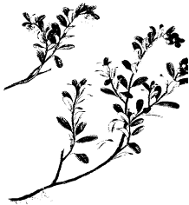
Fig Arctostaphylos uva-ursi
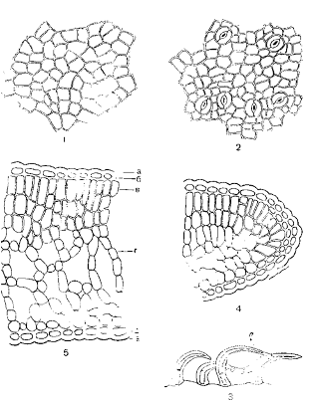
Fig. Folia Uvae ursi. 1 – Upper epidermis; 2 – Lower epidermis; 3 – Hairs; 4 – Cross section of leaf margin, 5 – Cross section : a – cuticle, б – upper epidermis, в – palisade parenchyma, г –spondy parenchyma, д – lower epidermis

Microscopical Characters.— According to the EP, The powder consists of fragments of epidermises which, seen in surface view, show polygonal cells covered by a thick smooth cuticle, and with straight, thick and irregularly pitted walls; anomocytic stomata, surrounded by 5 to 11 subsidiary cells and scars of hair bases only on the abaxial epidermis; fragments of palisade parenchyma, with 3 or 4 layers of cells of unequal lengths, and spongy parenchyma; groups of lignified fibres from the pericycle, with rows of cells containing prisms of calcium oxalate; occasional conical, unicellular covering trichomes.
Constituents.—The active principles are phenolic glycosides, represented by arbutin (6-10%) and methylarbutin. Upon hydrolysis, arbutin releases a diphenol which is immediately oxidized to hydroquinone. Note the presence of about 6-7 per cent of tannin, gallic acid, ellagic acid, a substantial quantity of gallotannins derived from pentagalloylglucose (15-20%). Flavonoids (quercetin), catechol, ursone, ursulic acid, iridoids triterpenes, monotropein (an iridoid), and picein (a glycoside of 4-hydroxy-acetophenone) have also been characterized in the drug.
Pharmacological Action. Uses.—Bearberry is diuretic and astringent and traditionally is used as adjunctive therapy in the diuretic treatment of benign urinary disorders, and to enhance the renal excretion of water. Hydroquinone is excreted in urine after conjugation as glucuronide and sulphate. In order for the antiseptic activity to occur, the urine must be alkaline (to allow hydrolysis of the conjugates) and the hydroquinone concentration sufficient.
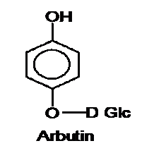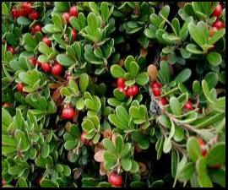

Dryopteris filix-mas

Botanical Origin.—Dryopteris filix-mas (L) Schott.
Engl. – Male Fern, European Aspidium;
Rus. – Папоротник мужской
Family – Dryopteridaceae (Aspidiaceae).

Part Used.—Rhizomata Filicis maris consists of the rhizome, frond bases and apical bud of Dryopteris filix-mas (L.)Schott., Dryopteridaceae (Aspidiaceae).
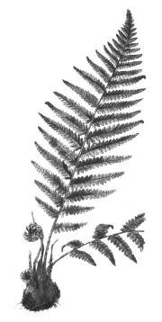
Fig. Dryopteris filix mas

Habitat.—Dryopteris filix-mas is found in the temperate zones of Europe, northern Asia and in North and South America.
Plant.—Perennial ferns with oblique rhizomes which are covered with stipe bases. From the anterior region of each arises a circle of broadly oblong-lanceolate or ovate-oblong bipinnate fronds. The pinnae or first divisions of the lamina of the frond are lanceolate and the pinnules or divisions of the pinnae, oblong. Sori are nearer the midvein than the margin.
MPM Description.—The drug occurs in pieces about 7-25 cm in length, consisting of a rhizome about 2 cm in diameter surrounded by frond bases which bring the total diameter of the pieces to about 4 or 5cm. Some of the larger pieces have been sliced to facilitate drying. The frond bases are brown externally and densely covered with ramenta; internally they are green, and show in transverse section from six to nine pale yellow meristeles (distinction from Athyrium filix-foemina). The rhizome is brownish externally and yellowish-green internally. On long storage the interior becomes brown, the activity decreases and the drug is no longer fit for use. A section of the rhizome shows from six to nine large meristeles arranged in a diffuse circle and external to these the smaller meristeles running from the fronds.
The drug has little odour. The taste is at first sweetish, afterwards becoming bitter and extremely nauseous.
Microscopical Characters. —Passing from periphery toward the rhizome center the following structures are to be observed:
1. Epidermis, a protective outer covering tissue, composed of a single layer of brownish polyhedral cells from which are given off ramenta. The latter show 2 small glands at their bases and the margins have 2-celled projections.
2. Outer cortex (hypodermis), a zone of several layers of orange to greenish-orange thick-walled, lignified, hypodermal cells separating the epidermis from the inner cortex beneath.
3. Inner cortex of several layers of more or less isodiametric cells (cells of nearly the same length, breadth and thickness) with thin cellulose walls and containing stored starch surrounded by a protoplasmic investment. Between the cells are to be noted intercellular-air spaces, into many of which project characteristic more or less pyriform, short-stalked oleoresin glands.
4. Pith composed of fundamental tissue, resembling the last in aspect and function.
5. Vascular bundles.—These are of two kinds, viz.: stem bundles and leaf-trace bundles. Both are of elliptical outline and of xylocentric type as seen in cross section, and are embedded in the parenchyma forming the broad central matrix. The stem bundles are comparatively broad and, as viewed in longitudinal sections, form a continuous network with good-sized meshes, each mesh being opposite the point of insertion of one of the leaves. In transverse section these bundles are seen to be arranged in an interrupted circle within the fundamental tissue. The leaf-trace bundles are comparatively narrow and are observed to come off of the stem-bundles and pass out through the cortex into the leaves (fronds). When each bundle is examined under a high-power magnification it is seen to consist of a central xylem, composed of scalariform or occasionally reticulate or reticulo-scalariform tracheids, which is completely surrounded by a phloem composed of rounded, thin-walled phloem cells and sieve tubes. Surrounding the bundle is a 1 to 3-layered pericycle an around this an endodermis or bundle sheath composed of a single layer of cells with yellowish walls and granular contents.
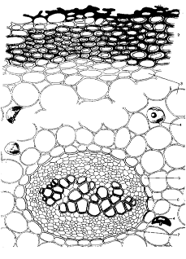
Fig. Cross section of Rhizomata Filicis maris

Constituents.—The active constituents of male fern are phloroglucinol derivatives which occur as mono-, bi-, tri- and tetracyclic compounds. Two or more molecules of the simple monocyclic derivatives such as aspidinol, filicinic acid and filicinyl butanone may condense to give bicyclic compounds such as albaspidin and flavaspidic acid, or tricyclic ones such as filicic acid. The drug and its extract are assayed for 'filicin', 'crude filicin' or 'crude filicic acid', a mixture of the ether-soluble acidic (phenolic) substances.
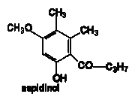
Tannins, triterpenoids, higher aliphatic fatty acids and alcohols and their esters also occur.
Pharmacological Action. Uses.—Male Fern has an anthelmintic effect and is strongly cytotoxic against band worms and liver flukes. The pharmacological effect is largely due to the flavaspidic acid with filicic acids being the main active principle.
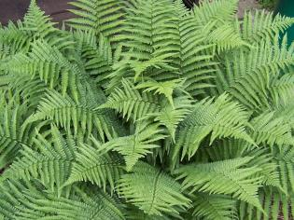
Dryopteris filix mas

Viola spp
Botanical Origin.— Viola tricolor L. Engl. – Heartsease, Wild Pansy; Rus. – Фиалка трёхцветная).
Family – Violaceae.

Part Used.—Herba Violae consists of dried flowering aerial parts of Viola arvensis Murray and/or Viola tricolor L., Violaceae.
Habitat.—The plant is indigenous to temperate Eurasia, from the Mediterranean to India and as far as Ireland. It is cultivated in Holland and France.

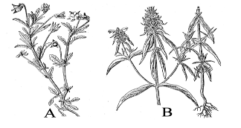
Fig. A - Viola tricolor; B - Melampyrum cristatum, Upper and lower plant parts

Plants.—Heartsease is annual to perennial and grows about 30 cm high. The shoots are usually yellowish green, glabrous or covered in scattered hairs. The stem is erect, angular, unbranched or branched, glabrous or shorthaired. It has short internodes below and longer ones above. The leaves are alternate, glabrous, or short-haired. The lower leaves are cordate; the upper ones are oblong-elliptical. The stipules are lyrate-pinnatesect and have a large, crenate terminal tip. The solitary, long-pedicled flower is yellow or tricolored. It has 5 lanceolate, acute and uneven sepals with an appendage and 5 uneven petals, the largest of which is spurred. The 5 stamens also have an appendage at the tip. There are 3 fused superior ovaries. The fruit is an ellipsoid, obtusely angular capsule, which bursts open at 3 points. The seeds are pear-shaped and yellow.
Adulteration.—Can rarely occur due to misidentification and admixture with the plants of the genus Melampyrum (see fig 7.12 B).
Table 7.2. Distinguishing diagnostic characters of Viola spp. and their adulterants

 | Leaves | Flowers
Viola tricolor L. | alternate, simple, bluntly dentate, cordate to oblong-ovate, pale green, much crumpled, up to 6-7 cm in length, 3 - 6 teeth on each side, stipules pinnatipartite; terminal segments largest | characteristic are the deep blue and bright yellow and/or pale violet to white, mostly curled up flowers and petals. The yellow, violet, or three-colored flowers are zygomorphic, about 2 mm in diameter, bearing a short spur
Viola arvensis Murray | alternate, simple, dentate; lower leaves ovate or orbicular-ovate, base rounded, petioles equaling or exceeding blades; middle leaves oblong-ovate or oblong-elliptic, base cuneate, decurrent into a short petiole; upper leaves oblong-lanceolate, with indistinct petioles, up to 2,5 cm in length, margin crenate or serrate, 2 - 5 teeth on each side; stipules pinnatipartite | few to numerous, up to 15 mm in diameter; corolla funnelform; petals yellow or ivory, obviously shorter than or nearly equaling sepals, 6-11 mm
Melampyrum cristatum L. | linear – lanceolate, acute, entire, upper – with 1 -2 teeth at the base, 3 -5 cm in length, no petioles | in dense cylindric spikes; purple corolla with yellow limb and margins; calyx campanulate and pubescent
Melampyrum nemorosum L. | opposite, short – petiolated, ovoid – lanceolate, entire, 3 - 8 cm in length, no petioles | in one-side raceme; upper bracts pale violet, corolla yellowish - golden

MPM Description.—According to the EP, The stem is angular and hollow. The leaves are oval, petiolate, with a cordate base or elongated and obtuse, with lyrate stipules, divided in the middle. The flowers, with a long peduncle, are zygomorphic, with 5 oval, lanceolate sepals, an appendage pointed outwards and 5 petals of which the lower one bears a spur; in Viola arvensis, the petals are shorter than the calyx, the lower petal is cream coloured, with black lines, the 4 upper petals may be cream coloured or violet blue; in Viola tricolor, the petals are longer than the calyx and violet coloured, more or less tinged with yellow. The androecium consisting of 5 stamens bears at the apex a membranous connective appendage with 2 spurs. The trilocular ovary shows a short style and globular stigmata. The fruit are navicular capsules, three-lobed, yellowish brown, 5 mm to 10 mm long. The pale yellow, pyriform seeds are about 1 mm long, bearing a caruncle. Leafy odour; taste slightly bitter and astringent.
Microscopical Characters.—Stem. Elongated epidermal cells with straight, slightly thickened anticlinal walls; cuticle strongly striated; infrequent parallel orientated stomata; covering trichomes, if present, unicellular with distinct cuticular striations; narrow cortex, collenchymatous near epidermis; stele, ring of collateral vascular bundles linked by areas of lignified, pitted parenchyma; parenchymatous pith. Cortical parenchyma may contain an occasional cluster crystal of calcium oxalate.
Leaf. Lamina, epidermal cells of both surfaces polygonal with sinuous anticlinal walls, more wavy on lower surface; stomata anisocytic, slightly more frequent on lower surface; cuticle striated, more prominently adjacent to stomata; over larger veins and margins, elongated, slightly thickened epidermal cells; frequent papillae or short, thickened, unicellular covering trichomes, up to 200 μm long, with distinct, cuticular striations; an occasional glandular trichome with multicellular, multiseriate stalk and head. Dorsiventral, two layers of palisade cells; spongy mesophyll cells contain clusters of calcium oxalate. 30-35 μm in diameter, in groups of two to six. Midrib with collateral bundle containing narrow 5 μm diameter, lignified, xylem conducting elements with spiral or annular thickening.
Flower. Characteristics of sepal resemble those of leaf. Petal short, rectangular or elongated, outer epidermal cells with sinuous, occasionally beaded, anticlinal walls, cuticle striated; inner epidermal cells, polygonal, mainly papillose with faintly striated cuticle; unicellular covering trichomes, 350-500 μm in length with longitudinal, cuticular striations and acute apices or distinctive wavy walled upper areas, occur at base of petals and particularly within the spur. Stamen, lignified fibrous layer of anther wall; spherical or squarish pollen grains, with three to five pores, up to 65 μm in diameter, exine smooth or finely warty. Pedicel, rectangular, slightly beaded epidermal cells; cuticle smooth; frequent parallel orientated stomata.
Fruit. Polygonal, yellow, collenchymatous epidermal cells with occasional anisocytic stomata; testa epidermis yellow, thin-walled, polygonal cells interspersed with two or three reticulate, slightly lignified cells; sclerenchyma layer composed of narrow, thick walled, lignified fibres accompanied by parenchyma layer, each cell containing a prism of calcium oxalate.

Fig. A - Viola tricolor; B - Melampyrum cristatum, Upper and lower plant parts
Fig 7.13. Viola tricolor. Histological characters. A - Upper epidermis. B - Lower epidermis. C - The leaf margin. D – Fragment of flower
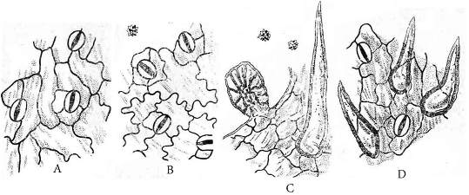
Powdered Drug.—According to the EP, The powder shows the following diagnostic characters: fragments of the epidermis of the leaves in surface view with wavy-walled cells and anomocytic stomata; conical unicellular covering trichomes, widened at the base and sharply pointed at the apex, with a striated cuticle; glandular trichomes with a multicellular head, and a short, multicellular stalk in the indentations of the leaf margins; cluster crystals of calcium oxalate, sometimes included in parenchyma; fragments of the corolla with wavy-walled epidermal cells, those from the mid-region papillose and with some extended to form flask or bottle-shaped projections, those from the base of the petals with covering trichomes up to about 300 μm long with characteristic hump-like swellings along their length; spherical or polyhedral pollen grains, 60 μm to 80 μm in diameter, with finely pitted exines and 5 pores (Viola arvensis) or 4 pores (Viola tricolor); occasional fragments of spiral and reticulate vessels and groups of fibres from the stem.
Constituens.—Aerial portion of herbs consists of salicylic acid, volatile oil (methylsalycilate), saponins (14%), mucilages, hydroxycoumarin umbelliferone, tannins; flavonoids (0.2-0.4%): including among others rutin violaquercitrin, luteolin-7-O-glucosides, scoparin, saponarine, violanthin, vitexin. The EP requires minimum 1.5 per cent of flavonoids, expressed as violanthin (dried drug).
Pharmacological Action. Uses.—Infusion is expectorant, diuretic and anti-inflammatory. The drug has soothing, salve-like effects due to its mucin content; in animal experiments oral administration brought about an improvement of eczema-like skin conditions after long-term use.
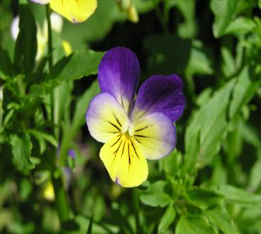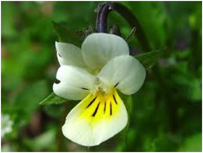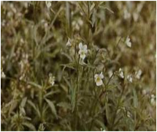
Viola arvensis
Podophyllum peltatum

Botanical Origin.—Podophyllum peltatum L.
Engl. — Mandrake, MayApple;
Rus. — Подофилл щитовидный
Family – Berberidaceae.

Part Used.—Rhizomata et radices Podophylli consist of the dried rhizomes and roots of Podophyllum peltatum L., Berberidaceae.
Habitat.—Eastern and central North America.
Plant.—A perennial herb whose underground portion consists of a long, brown, jointed and branched rhizome bearing thick fibrous roots from the lower surface of its various nodes. Its aerial portion consists of two kinds of stems which arise from separate nodes of the rhizome. One of these, the flowering stem, bifurcates at its summit to form 2-stalked 5- to 7-lobed leaves from the fork of which arises a stalked, nodding, white flower. The other, the flowerless stem, terminates in a peltate, 7- to 9-lobed leaf. The flower consists of 6 caducous sepals, 6 to 9 obovate white petals, 12 to 18 hypogynous stamens, a fleshy pistil with ovate ovary and sessile stigma. The fruit is an ovate berry about the size of a small lemon.
MPM Description.—In subcylindrical jointed pieces, usually showing a node and long internode region, from 4 to 20 cm in length, the node being up to 15 mm, the internode up to 9 mm in diameter, compressed above and below; externally dusky red to light yellowish-brown, smooth or slightly longitudinally wrinkled with somewhat V-shaped scars of scale leaves; some of the nodes annulate; upper surface of nodes marked with large deeply depressed, circular stem scars and sometimes with buds or stem-bases; lower surface of nodes, and at times portions of internodes adjacent to them, showing numerous white root scars or roots that may attain a length of 7 cm and a thickness of 2.5 mm; fracture, of both rhizome and root weak, brittle and even; internally, bark of rhizome grayish-white, of root white, wood of rhizome, showing a circle or ellipse or isolated yellowish-orange to pale yellow xylem masses, within which region - a large grayish-white pith, central region of root showing a pale yellow bundle; odour indistinct; taste disagreeably bitter and acrid.
Microscopical Characters.—Transverse sections made through the internode of the rhizome show the following structures:
Epidermis of reddish-brown cells with suberized outer and radial walls
2. Cortex of about 20 layers of rounded cortical parenchyma cells containing numerous spheroidal, polygonal or 2- to 6-compound starch grains.
3. Fibrovascular bundles of the open collateral type 16 to 34 in number and arranged in an interrupted circle or an ellipse. Medullary rays separate the bundles and unite the cortex with the pith.
4. Pith, a broad zone of parenchyma similar in nature to that found in the cortex.
Sections made through the nodes show the presence of rosette aggregates calcium oxalate in certain of the parenchyma cells.
Constituents.—The drug contains 3 to 6% resin. Known in the past as podophyllin, this resin can be obtained by diluting an alcoholic extract with water that is eventually acidified: it precipitates, is collected, then dried. The main constituents of the resin are 1-aryltetrahydronaphthalenes (lignans): podophyllotoxin (20%), α- and β-peltatins (5 and 10%, respectively), desoxypodophyllotoxin, and close derivatives. Some of these compounds occur as glycosides.
Pharmacological Action. Uses.—Podophyllotoxin from Podophyllum peltatum is an active antitumour drug. The antimitotic and purgative properties depend on a lactone ring in the trans configuration. Preparations of Mayapple are used externally for removal of pointed condyloma.
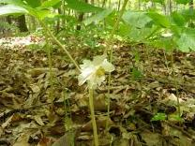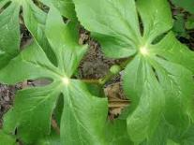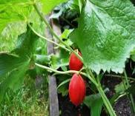

Podophyllum peltatum

Vaccinium vitis-idaea

Botanical Origin.—Vaccinium vitis-idaea L.
Engl. – Lingon-Berry, Mountain Сranberry, Fox Berry;
Rus. – Брусника обыкновенная.
Family – Ericaceae.
Parts Used.—Folia Vitis idaea, Cormus Vitis idaeae consists of leaves and corms of Vaccinium vitis idaea, Ericaceae.
Habitat.—Arctic regions of North America and Eurasia. Grows on shallow, poorly developed mineral soil as well as on drained peat.
Plant.—A low, creeping, evergreen subshrub that commonly reaches 5-12 cm in height. It typically grows in dense rhizomatous colonies and frequently forms mats. Stems semi-woody, slender and trailing, bearing numerous shoots 1-2 mm in diameter. Roots consist of tap roots with finely divided rootlets at the extremities and adventitious roots occurring at nodes along creeping stems and rhizomes. The branched rhizomes have numerous hairlike roots. 80% of the total biomass of mature plants is underground. Leaves simple, thick, leathery, and evergreen; are obovate, oblong, or elliptic, alternating in a spiral. Upper surface dark green; the lower surface pale green, waxy with black glandular dots, turning purplish in fall. Leaves may persist for up to 3 years. Flowers develop from buds initiated the previous year, occurring on terminal racemes singly or in groups of up to 15. Fruit a bright to dark red, globular berry approximately 1/4 to 1/2 cm in diameter. The four-celled berries are acidic to sour or bitter. Yellow, short-beaked seeds average 0.04 cm in length.
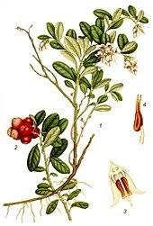Fig. Vaccinium vitis idaea
MPM Description.—The drug occurs as small, leathery, narrowly elliptic to egg-shaped, 6-15 mm long leaves, rounded at tip, shiny, dark green above, pale with dark dots below; edges smooth, rolled under. Leaves distributed along the stems; evergreen. Stipules absent. Petioles present; 1-1.5 mm long; hairy. Petioles hairs reflexed; curved. Leaf blade bases acute. Blades length-width ratio 3. Blades leathery; oblong, or elliptic; flat (margins slightly rolled under); appearing single-veined. Blades adaxial surface shiny (lustrous when fresh); without sessile glands; glabrous. Blades abaxial surface with sessile glands (that appear as sparse, small brown dots), glabrous (ligther in colour than adaxial surface). Blade margins entire; glabrous. Leaf apices obtuse, or rounded.
Microscopical Characters.—Cells of both leaf epidermises with slightly wavy walls. Elliptical stomata small, with two neighboring cells along the stomata cells (paracytic type). Lower epidermis has glandular hairs, which consist of multicellular stalk that gradually pass into multicellular head with brown contents. Unicellular straight or curved hairs with thick cell walls and smooth surface rarely occur along veins. Mesophile contains rarely single prismatic CaC₂O₄ crystals.

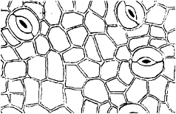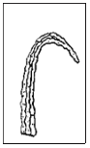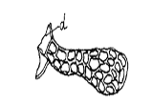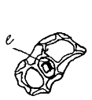
Fig. Fragments of microscopic structure of Folia Vitis idaeae
a - Lower epidermis
d – Glandular hairs
b – Hairs along veins
e - Prismatic crystals of CaC₂O₄
Constituents.—The plant yields phenolic glycosides arbutin (5-7%), methylarbutin (3%); phenolic and oxycinnamic acids (coffeic, ferulic, chlorogenic); flavonoids; triterpenes; tannins (20%).
Pharmacological Action. Uses. —Antiseptic, diuretic, astringent in kidney stone disease and cystitis. Diuretic and mild disinfectant to urinary tract. In folk medicine the leaves and fruits are used. Prepara­tions made from the leaves are used to treat bladder problems, gout, and rheumatism. Medicinal fruit jellies are used to treat sore throats and colds.
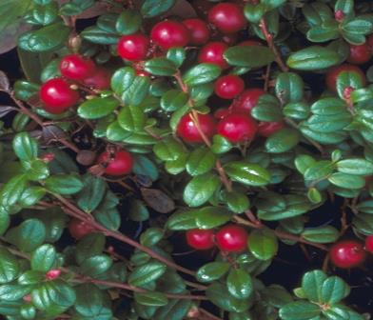

Lignans
Classification of lignans
Lignans (C6-C3-C3-C6) are dimers of phenylpropane (C6-C3)2 derivatives, combined with C-C linkages between middle carbon atoms of side chains.
syringoresinol
schizandrine
podophyllotoxin
silibin

Lignans are spread in Araliaceae, Berberidaceae, Pinaceae, Schizandraceae,being the constituents of resin exudate trees and bushes.
Lignans and neolignans are typically found as dimeric phenylpropanoid derivatives chemically related to the polymeric lignins of the plant cell and are found in woody tissues. Neolignans are formed by unsymmetrical carbon-carbon links in the side chains.
Norlignans—these are biogenetically close to lignans (and probably specific for gymnosperm types), though structurally resemble neolignans more; they are de facto lignan derivatives with a lower number of carbons (substances of diphenylbutadiene type C₆–C₄–C₆, or conioids C₆–C₅–C₆) and the presence of other, often even conjugate double bonds.
Hybrid lignans—the term refers to their mixed biogenetical origin: they are flavono-lignans (e.g., so called silymarin in Silybum marianum achenes, hydnocarpin in Hydnocarpus wightiana seeds), coumaro-lignans (hyosgerin from Hyoscyamus niger seeds), or xantolignans (kielcorin from Hypericum spp. roots).
Into this group also belong so-called lignoids, e.g., crinasiatin from Crinum asiaticum tubers, representing the first lignophenanthridine alkaloid, or a range of macrocyclical spermine alkaloids, e.g., orantine, hordatine, aphelandrine, etc., in whose molecules neolignan substructures can be found.
An important part is played by furano-furanoid lignans (more precisely dibenzylbutanes), contained in important pharmaceutical and food materials, e.g., seeds of cultivated flax (Linum usitatissimum).
A great reservoir of lignans is constituted by resins of gymnosperm types, containing lariciresinol and pinoresinol, hydroxymatairesinol and substances of sesamine type, and their occurrence is quite common in everyday plant food (cereals, rice, soya, some nuts, seeds, and fruits) and natural beverages (white and red wine)
Physicochemical properties
Lignans are colourless crystallic substances, soluble in fixed and volatile oils, resins, chloroform, benzene, diethylester. They occur in plants as aglycones and glycosides, often dissolved in fixed and volatile oils, resins. Lignans develop yellow or blue fluorescence in UV light.
For lignans extraction ethanol and petroleum ethers, benzene and chloroform are used with further fractionation by column chromatography on silica gel and aluminium oxide. TLC serves usually in the final step for purification of lignans.

Extraction
Extraction in the Soxhlet extractor is a common, probably the most widely used method; it can be used for sequential extraction (the use of solvents or their mixtures with increasing polarity), which is usually started with petroleum ether, n-hexane, or a halogenated hydrocarbon; this procedure is especially important in the case of seeds or fruits with a high lipid content. After removing lipidic substances, polar solvents (ethanol, methanol, and acetone) are used for preparation of total extracts, often with addition of a certain amount of water. For the extraction of polyphenols inclusive lignans of grains 30% acetone can also be successfully used. Most aglycones have low to medium polarity and must be extracted with relatively nonpolar solvents.
Purification of total extracts with lignan content is quite time-consuming and laborious; it is though suitable to carry it out because in following TLC it makes analysis significantly easier. Methanol extracts are usually concentrated, diluted with water, this suspension fractioned with n-hexane and consequently with chloroform, dichloromethane, or ethyl acetate with the aim to obtain a lignan fraction.

Detection
Lignans may be characterized by reactions for phenolics: with ferric salts, dinitroreagents, alkali and other. Very usable is copulation reaction of phenolic hydroxyl group with diazotized compounds. Identification of the predominant lignans is facilitated by specific colours obtained by colouring agents. Spraying with sulphuric acid in ethanol followed by rapid heating gives different colours to lignans: violet, red or red-brown, dark gray, and blue.
As lignans absorb UV light, they are readily detected at 254 nm using the plates with fluorescent indicator. Alternatively, the spots on developed plates can be temporarily visualized by plate exposure to iodine vapor. Some lignans give characteristic blue fluorescent spots under UV light.
Chromatographical analysis
TLC as a simple, inexpensive, and rapid method is applied mostly for a first qualitative examination of plant extracts and for monitoring various stages of lignin purification. It is possible to obtain good results by TLC especially because most lignans are substances of lower or medium polarity and therefore TLC can be successfully used mainly in the form of adsorption chromatography.
Simple mixtures of these substances may be separated by PC in butanol acetic acid - water and 15% acetic acid. More complex mixtures can be separated using butanol - acetic acid - aqueous molybdic acid on chromatography paper previously impregnated with dilute molybdic acid. Complex mixtures may also be resolved by TLC on silica gel using such solvents as ethyl acetate - methanol (19: 1) or benzene - ethanol (9: 1).
Unfortunately, there does not seem to be a specific spray reagent, which distinguishes lignans from other simple phenols. Lignans can be seen as dark absorbing spots on paper in short UV light or can be revealed by spraying with 10% antimony chloride in chloroform. On TLC plates, they are detected by spraying with conc. H₂S0₄. Lignans can be further identified by spectral means; they show absorption at 280 – 284 nm, this band being shifted to about 298 nm in the presence of alkali.
The progress in instrumentation has led HPTLC densitometry to an improvement of its reliability, making this technique competitive with HPLC-UV detection.
Biological activity of lignans
Lignans and neolignans play an important role in the plant defense as antimicrobial, antifungal, and antifeedant agents. Because they have antitumor and antiviral activity, lignans are of considerable pharmacological interest.
Podophyllotoxin from Podophyllum peltatum, Berberidaceae is an active antitumour drug. Schizandrine, obtained from fruits of Schizandra chinensis, Schizandraceae is stimulating and adaptogenic agent. The same actions, due to syringoresinole, have rhizomes and roots of Eleutheroccocus senticosus, Araliaceae. Flavonoglycans of Silybum marianum, Asteraceae cause hepatoprotective action.
Among the lignans of other structural groups, substances of dibenzocyclooctadiene type isolated from Schisandra chinensis seeds are beginning to play an important part. Out of the total of about 50 compounds the main lignans schizandrin, deoxyschisandrin, gomisin are worth mentioning. They exhibit antioxidative, hepatoprotective and neurotrophic activity; the hepatoprotective activity is considered to be the most significant effect. It is based on an increase of glutathione content in tissues and protection against oxidative stress.
Much attention is still attracted by other biologically active types of phenylpropane condensates, flavonolignans from Silybum marianum achenes represented by so-called silymarin complex, namely the mixture of silybins (silybin A), isosilybins, silydianin, and silychristin with an important antioxidative, but especially hepatoprotective activity, and prospective neolignans magnolol and honokiol, contained in Magnolia officinalis bark is an important medicinal drug in Oriental medicine.
Antiinvasive effects (antimicrobial, antifungal, antiviral, antineoplastic) of lignans are important. Lignans of aryltetraline type - podophyllotoxin, 4’-demethylpodophyllotoxin, α-peltatine, β-peltatine from rhizomes and roots of Podophyllum peltatum and their semisynthetic derivatives etoposide and teniposide are employed currently; while the use of podophyllotoxin is limited (external for treatment of condylomas), etoposide and teniposide have become important parts of therapeutic schemes in treatment of some neoplasms.
MPM name | Source | Constituents | Action, use
Rhizomata et Radices Podophylli | Podophyllum peltatum L. (podophyllum), Berberidaceae | 3 to 6% resin (lignans podophyllotoxin (20%), a- and b-peltatins (5 and 10% respectively), desoxypodophyllotoxin, and close derivatives | podophyllotoxin is an active antitumour drug
Semina Silybi | Silybum marianum (L.) Gaertn (St.Mary thistle, blessed milk thistle), Asteraceae. | flavonolignans. (silymarin 1.5 to 3%; silybin, silydianin, silychristin) lipids; proteins; flavonoids | hepatoprotective properties due to flavonolignans
Rhizomata et Radices Eleutherococci | Eleutherococcus senticosus (Rupr. et Maxim.) Maxim.  (Eleutherococcus, Siberian Ginseng), Araliaceae | 8 eleutherosides (lignans, triterpene saponins, coumarins); volatile oil and resins. The main lignan is syringoresinol | CNS stimulant and adaptogenic, decreases sugar level in blood
Fructus Schizandrae, Semen Schizandrae | Schizandra chinensis (Turcz.) Baill., Schizandraceae | lignans (in the seeds 5 to 20%): dibenzo[a,c]cyclooctene derivatives, including schizandrine A to C, schizandrol A and B, schizantherine A and B, gomisins; fatty oil (in the seeds): chief fatty acids oleic acid and linoleic acid; volatile oil. | Schisandra fruits and seeds are believed to bring about a non-specific increase in physical performance ability. Tinctures from bark and seeds are used as the CNS stimulants

Schizandra chinensis

Botanical Origin.—Schizandra chinensis (Turcz.) Baill.
Engl. — Schisandra;
Rus. —Лимонник китайський
Family – Schizandraceae.

Parts Used.—Fructus Schizandrae, Semen Schizandrae consist of the dried, ripe fruit / seeds of Schizandra chinensis (Turcz.) Baill., Schizandraceae.
Habitat.—The plant is indigenous to northeastern China and Korea.
Plant.—The liana can be monoecious or dioecious. The leaves are alternate. They are arranged like whorls on short shoots. The petiole is 1 to 4 cm long. The lamina is 5 to 11 cm long, 3 to 9 cm wide, elongate to ovate elliptical, serrate to dentate with up to 3 teeth per cm. The upper surface is green or brown. The lower surface is partly pubescent. The young branches are brown to purple. The flowers are in clusters with a few blossoms in the axils of the bracts. There are 6 to 8 tepals. The perigone of the male flowers has 6 to 8 tepals that are 6 to 11 mm long and 5 mm wide, and 5 to 15 stamens. The female flowers have a similar perigone and 17 to 40 elongated, elliptical ovaries.
MPM Description.—The round, fleshy, berry-like fruit grows as a slim, hanging aggregate or as bloomed individual fruits. The fruit is deep red to black-brown and appears partly white-powdered. The fruit has a diameter of 5 to 8 mm and contains 1 or 2 reniform seeds.
Constituents.—Lignans (in the seeds 5 to 20%): dibenzo[a,c]cyclooctene derivatives, including schizandrine A to C, schizandrol A and B, schizantherine A and B, gomisins; fatty oil (in the seeds): chief fatty acids oleic acid and linoleic acid; volatile oil.
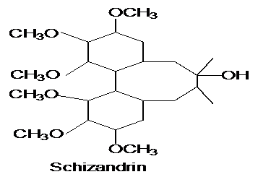
Pharmacological Action. Uses.—Schisandra fruits and seeds are believed to bring about a non-specific increase in physical performance ability. Tinctures from bark and seeds are used as the CNS stimulants. The lignans isolated from the drug (schizandrin, schizandrol) are liver-protective in effect, acting as radical scavengers and promoting liver regeneration. Anti-inflammatory and tumour inhibiting characteristics have also been demonstrated.
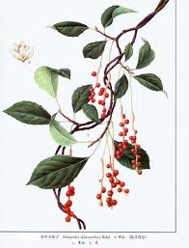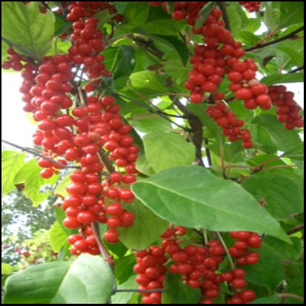
Eleutherococcus senticosus

Botanical Origin.—Eleutherococcus senticosus (Rupr. et Maxim.) Maxim.
Engl. — Siberian Ginseng, Eleuthero;
Rus. — Элеутерокок колючий,
Family – Araliaceae.
Part Used.—Rhizomata et Radices Eleutherococci consist of the dried, whole or cut underground organs of Eleutherococcus senticosus (Rupr. et Maxim.) Maxim., Araliaceae.
Habitat.—Siberian Ginseng grows in Siberia, northern China, Korea and Japan; in woods and mountains.
Plant.—Siberian Ginseng is a 1 to 3 m high perennial shrub whose branches are thickly covered with pale, thorny bristles pointing downward at an angle. The 5-palmately compound leaves are in groups of 5 and are thorny-serrate. The petiole is covered in fine bristles. The flowers are in umbels. The central umbel is on a long, thick peduncle. The style is fused into a column to the tip and has 5 small stigma lobes. The male flowers are violet, female - yellowish. The fruit is a subglobular, dark purple berry with 5 seeds.

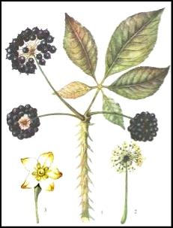 m,jj Q

Fig. Eleutelococcus senticosus
MPM Description.—According to the EP, The rhizome is knotty, of irregular cylindrical shape, 1.5 cm to 4.0 cm in diameter; the surface is rugged, longitudinally wrinkled and greyish-brown to blackish-brown; the bark, about 2 mm thick, closely adheres to the xylem; the heartwood is light brown and the sapwood is pale yellow; the fracture shows short thin fibres in the bark and is coarsely fibrous, especially in the internal part of the xylem. The lower surface bears numerous cylindrical and knotty roots, 3.5 cm to 15 cm long and 0.3 cm to 1.5 cm in diameter; with a smooth, greyish-brown to blackish-brown surface; the bark is about 0.5 mm thick, closely adhering to the pale yellow xylem; the fracture is slightly fibrous; in places where the outer layer has been removed, the outer surface is yellowish-brown.
Odour aromatic; taste mucilaginous, pungent and slightly acrid.
Powdered Drug.—According to the EP, The powder is yellowish-brown. The powder shows numerous groups of thick-walled, lignified fibres; fragments of reticulate and bordered pitted vessels with a wide lumen; groups of secretory canals, up to 20 µm in diameter with brown contents; parenchymatous cells containing cluster crystals of calcium oxalate 10 µm to 50 µm in diameter. The powder shows small starch granules, rounded to slightly angular in outline, single compounds or with 2 or 3 components.
Constituents.—Triterpene saponins: eleutheroside I, eleutheroside K (β hederin), eleutheroside L, eleutheroside M (hederasaponin B), for all of these aglycone oleanolic acid. Lignans: sesamine, eleutheroside D (epimeric diglucosides of syringaresinols). Steroids: including β -sitosterol-3-O-β -D-glucoside (daucosterol, eleutheroside A, 0.1%). Phenylacrylic acid derivative eleutheroside B. Immunostimulatingly effective polysaccharides (eleutherane A-G). Resin. Gums. Chlorogenic acid. Hydroxycoumarin isofraxidin.
According to the EP, Minimum 0.08 per cent for the sum of eleutheroside B (M_{r} 372.4) and eleutheroside E (M_{r} 742.7).
Pharmacological Action. Uses.—The liquid extract of the drug has an adaptogenic, central nervous system and immune-stimulating, immune-modulating and antiviral effect. Hypoglycemic effects have also been demonstrated with the herb along with enhancement of platelet aggregation-inhibiting effects. Approved by Commission E uses include lack of stamina and tendency to infection. Siberian Ginseng is used as a tonic for in times of fatigue and debility or declining capacity for work and concentration, and during convalescence. Siberian Ginseng is used in Chinese medicine for kidney pain, retention of urine, impotence, sleep disturbance, loss of appetite, pain and weakness in the hip and knee joints, rheumatoid arthritis and as a stimulant for the immune system.
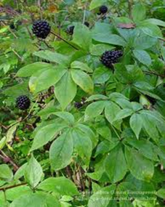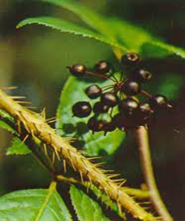

Podophyllum peltatum

Botanical Origin.—Podophyllum peltatum L.
Engl. — Mandrake, May Apple;
Rus. — Подофилл щитовидный.
Family – Berberidaceae.
Part Used.—Rhizomata et radices Podophylli consist of the dried rhizomes and roots of Podophyllum peltatum L., Berberidaceae.
Habitat.—Eastern and central North America.
Plant.—A perennial herb whose underground portion consists of a long, brown, jointed and branched rhizome bearing thick fibrous roots from the lower surface of its various nodes. Its aerial portion consists of two kinds of stems which arise from separate nodes of the rhizome. One of these, the flowering stem, bifurcates at its summit to form 2-stalked 5- to 7-lobed leaves from the fork of which arises a stalked, nodding, white flower. The other, the flowerless stem, terminates in a peltate, 7- to 9-lobed leaf. The flower consists of 6 caducous sepals, 6 to 9 obovate white petals, 12 to 18 hypogynous stamens, a fleshy pistil with ovate ovary and sessile stigma. The fruit is an ovate berry about the size of a small lemon.
MPM Description.—In subcylindrical jointed pieces, usually showing a node and long internode region, from 4 to 20 cm in length, the node being up to 15 mm, the internode up to 9 mm in diameter, compressed above and below; externally dusky red to light yellowish-brown, smooth or slightly longitudinally wrinkled with somewhat V-shaped scars of scale leaves; some of the nodes annulate; upper surface of nodes marked with large deeply depressed, circular stem scars and sometimes with buds or stem-bases; lower surface of nodes, and at times portions of internodes adjacent to them, showing numerous white root scars or roots that may attain a length of 7 cm and a thickness of 2.5 mm; fracture, of both rhizome and root weak, brittle and even; internally, bark of rhizome grayish-white, of root white, wood of rhizome, showing a circle or ellipse or isolated yellowish-orange to pale yellow xylem masses, within which region - a large grayish-white pith, central region of root showing a pale yellow bundle; odour indistinct; taste disagreeably bitter and acrid.
Microscopical Characters.—Transverse sections made through the internode of the rhizome show the following structures:
Epidermis of reddish-brown cells with suberized outer and radial walls
2. Cortex of about 20 layers of rounded cortical parenchyma cells containing numerous spheroidal, polygonal or 2- to 6-compound starch grains.
3. Fibrovascular bundles of the open collateral type 16 to 34 in number and arranged in an interrupted circle or an ellipse. Medullary rays separate the bundles and unite the cortex with the pith.
4. Pith, a broad zone of parenchyma similar in nature to that found in the cortex.
Sections made through the nodes show the presence of rosette aggregates calcium oxalate in certain of the parenchyma cells.
Constituents.—The drug contains 3 to 6% resin. Known in the past as podophyllin, this resin can be obtained by diluting an alcoholic extract with water that is eventually acidified: it precipitates, is collected, then dried. The main constituents of the resin are 1-aryltetrahydronaphthalenes (lignans): podophyllotoxin (20%), α- and β-peltatins (5 and 10%, respectively), desoxypodophyllotoxin, and close derivatives. Some of these compounds occur as glycosides.
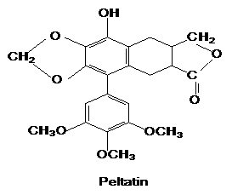
Pharmacological Action. Uses.—Podophyllotoxin from Podophyllum peltatum is an active antitumour drug. The antimitotic and purgative properties depend on a lactone ring in the trans configuration. Preparations of Mayapple are used externally for removal of pointed condyloma.
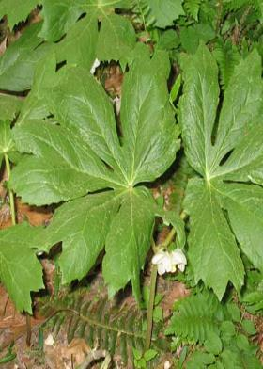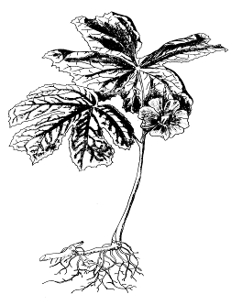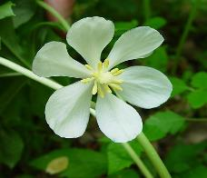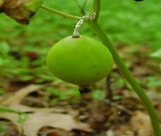

Rhodiola rosea
Family: Crassulaceae

Rhodiola rosea (commonly golden root, rose root, roseroot, Aaron's rod, Arctic root, king's crown, lignum rhodium, orpin rose)
Is a perennial flowering plant in the family Crassulaceae. It grows naturally in wild Arctic regions of Europe (including Britain), Asia, and North America, and can be propagated as a groundcover. Although it has long been used in traditional medicine for several disorders, notably including treatment of anxiety and depression, there is little scientific evidence to verify any benefit
Distribution
Rhodiola rosea grows in cold regions of the world, including much of the Arctic, the mountains of Central Asia, scattered in eastern North America and mountainous parts of Europe. It grows on sea cliffs and on mountains at high altitude
Description
Rhodiola rosea is from 5 to 40 centimetres (2.0 to 15.7 in) tall, fleshy, and has several stems growing from a short, scaly rootstock. Flowers have 4 sepals and 4 petals, yellow to greenish yellow in color sometimes tipped with red, about 1 to 3.5 millimetres (0.039 to 0.138 in) long, and blooming in summer. Several shoots growing from the same thick root may reach 5 to 35 centimetres (2.0 to 13.8 in) in height. R. rosea is dioecious – having separate female and male plants.
Chemical constituents
About 140 chemical compounds are in the subterranean portions of R. rosea. Rhodiola roots contain phenols, rosavin, rosin, rosarin, organic acids, terpenoids, phenolic acids and their derivatives, flavonoids, anthraquinones, alkaloids, tyrosol, and salidroside.
Plant part and form: Rhodiola rosea raw material is sold in the United States in bulk, either in the form of dried rhizome, dried rhizome/root, or standardized extracts of dried rhizome or dried rhizome/root. According to the United States Pharmacopeia (USP), the raw plant mate- rial consists of the dried roots and rhizomes of R. rosea L. containing not less than (NLT) 0.3% of the phenylpropanoid glycosides rosarin, rosavin and rosin (these three compounds are also collectively referred to as ‘rosavins’) calculated as rosavin, and NLT 0.08% of salidroside, calcu- lated on a dry weight basis. Hydro-alcoholic extracts of R. rosea roots and rhizomes should contain NLT 90.0% and not more than (NMT) 110.0% of the labeled amount of the above-mentioned phenylpropanoid glycosides (rosavins), and NLT 90.0% and NMT 110.0% of the labeled amount of salidroside. In Canada, R. rosea is sold as the dried root/rhizome, as an extract (standardized to contain 1–6% rosavins, or 0.8–3% salidroside), or as a tincture. Rhodiola rosea is sold in the European Union (EU) as dried root/ rhizome, an herbal tincture or dry extract, (drug:extract ratio 1.5–5:1, extraction solvent 67–70% ethanol, v/v).
General use(s): Rhodiola rosea has a long history of use as a medicinal plant, appearing in the body of collected knowledge (materia medica) of many European countries15 and included in several traditional herbal systems in Asia and North America.Between 1748 and 1961, diverse medicinal applications for R. rosea have been reported in the scientific literature of Sweden, Norway, France, Germany, Iceland, and the Soviet Union, principally considered as an adaptogen, or an agent stabilizing physiological processes and promoting homeostasis, with various health-promoting effects. In Europe it is considered a traditional herbal medicinal product used for temporary relief of stress symptoms, such as fatigue and sensation of weakness. Uses in the EU, Australia, and New Zealand include support of cognitive function, such as mental focus and mental stamina, a source of antioxidants, and a source of immune function-enhancing constituents. In North America and Brazil, it is primarily used as an adaptogen, and to improve athletic performance by reducing recovery time after prolonged exercise. In Central Asia, R. rosea was used traditionally as a remedy for the prevention and treatment of cold and flu. In Mongolia, R. rosea is traditionally used for fever, lung inflammation, and strengthening of the body, as well as a mouthwash for bad breath. Mongolian doctors also prescribe it as a medicine for tuberculosis and cancer.
Traditional medicine
In Russia and Scandinavia, R. rosea has been used for centuries to cope with the cold Siberian climate and stressful life. It is also used to increase physical endurance and resistance to high-altitude sickness,[medical citation needed] but the scientific evidence for such benefits is weak. The plant has been used in traditional Chinese medicine, where it is called hóng jǐng tiān.

Arctostaphylos uva-ursi
Botanical Origin.—Arctostaphylos uva-ursi L.
Engl.—Bearberry, Red Bearberry, Mountain Box, Rockberry;
Rus. - Толокнянка обыкновенная, медвежье ушко).
Family – Ericaceae.

Part Used.—Folia Uvae ursi consists of whole or cut, dried leaf of Arctostaphylos uva-ursi (L.) Spreng., Ericaceae.
Habitat.—In gravelly or sandy soil of northern Europe, Asia and North America.
Plant.—Procumbent evergreen shrubs with trailing stems bearing short ascending branches which in turn bear leaves that have an ovate, ovate-spatulate to spatulate outline.

MPM Description.—According to the EP, The leaf, shiny and dark green on the adaxial surface, lighter on the abaxial surface, is normally 7 mm to 30 mm long and 5 mm to 12 mm wide.
Constituents.—The active principles are phenolic glycosides, represented by arbutin (6-10%) and methylarbutin. Upon hydrolysis, arbutin releases a diphenol which is immediately oxidized to hydroquinone. Note the presence of about 6-7 per cent of tannin, gallic acid, ellagic acid, a substantial quantity of gallotannins derived from pentagalloylglucose (15-20%). Flavonoids (quercetin), catechol, ursone, ursulic acid, iridoids triterpenes, monotropein (an iridoid), and picein (a glycoside of 4-hydroxy-acetophenone) have also been characterized in the drug.
Pharmacological Action. Uses.—Bearberry is diuretic and astringent and traditionally is used as adjunctive therapy in the diuretic treatment of benign urinary disorders, and to enhance the renal excretion of water. Hydroquinone is excreted in urine after conjugation as glucuronide and sulphate. In order for the antiseptic activity to occur, the urine must be alkaline (to allow hydrolysis of the conjugates) and the hydroquinone concentration sufficient.

Dryopteris filix-mas
Botanical Origin.—Dryopteris filix-mas (L) Schott.
Engl. – Male Fern, European Aspidium;
Rus. – Папоротник мужской
Family – Dryopteridaceae (Aspidiaceae).

Part Used.—Rhizomata Filicis maris consists of the rhizome, frond bases and apical bud of Dryopteris filix-mas (L.)Schott., Dryopteridaceae (Aspidiaceae).
Habitat.—Dryopteris filix-mas is found in the temperate zones of Europe, northern Asia and in North and South America.
Plant.—Perennial ferns with oblique rhizomes which are covered with stipe bases. From the anterior region of each arises a circle of broadly oblong-lanceolate or ovate-oblong bipinnate fronds.
MPM Description.—The drug occurs in pieces about 7-25 cm in length, consisting of a rhizome about 2 cm in diameter surrounded by frond bases which bring the total diameter of the pieces to about 4 or 5cm.
The drug has little odour. The taste is at first sweetish, afterwards becoming bitter and extremely nauseous.
Constituents.—The active constituents of male fern are phloroglucinol derivatives which occur as mono-, bi-, tri- and tetracyclic compounds. Two or more molecules of the simple monocyclic derivatives such as aspidinol, filicinic acid and filicinyl butanone may condense to give bicyclic compounds such as albaspidin and flavaspidic acid, or tricyclic ones such as filicic acid. The drug and its extract are assayed for 'filicin', 'crude filicin' or 'crude filicic acid', a mixture of the ether-soluble acidic (phenolic) substances.
Tannins, triterpenoids, higher aliphatic fatty acids and alcohols and their esters also occur.
Pharmacological Action. Uses.—Male Fern has an anthelmintic effect and is strongly cytotoxic against band worms and liver flukes. The pharmacological effect is largely due to the flavaspidic acid with filicic acids being the main active principle.
Dryopteris filix mas

Viola
Botanical Origin.— Viola tricolor L. Engl. – Heartsease, Wild Pansy;
Rus. – Фиалка трёхцветная). Family – Violaceae.

Part Used.—Herba Violae consists of dried flowering aerial parts of Viola arvensis Murray and/or Viola tricolor L., Violaceae.
Habitat.—The plant is indigenous to temperate Eurasia, from the Mediterranean to India and as far as Ireland. It is cultivated in Holland and France.
Plants.—Heartsease is annual to perennial and grows about 30 cm high. The shoots are usually yellowish green, glabrous or covered in scattered hairs. The stem is erect, angular, unbranched or branched, glabrous or shorthaired. The fruit is an ellipsoid, obtusely angular capsule, which bursts open at 3 points. The seeds are pear-shaped and yellow.
MPM Description.—According to the EP, The stem is angular and hollow. The leaves are oval, petiolate, with a cordate base or elongated and obtuse, with lyrate stipules, divided in the middle. The flowers, with a long peduncle, are zygomorphic, Leafy odour; taste slightly bitter and astringent.
Constituens.—Aerial portion of herbs consists of salicylic acid, volatile oil (methylsalycilate), saponins (14%), mucilages, hydroxycoumarin umbelliferone, tannins; flavonoids (0.2-0.4%): including among others rutin violaquercitrin, luteolin-7-O-glucosides, scoparin, saponarine, violanthin, vitexin. The EP requires minimum 1.5 per cent of flavonoids, expressed as violanthin (dried drug).
Pharmacological Action. Uses.—Infusion is expectorant, diuretic and anti-inflammatory. The drug has soothing, salve-like effects due to its mucin content; in animal experiments oral administration brought about an improvement of eczema-like skin conditions after long-term use.
Viola arvensis

Podophyllum peltatum

Botanical Origin.—Podophyllum peltatum L.
Engl. — Mandrake, MayApple;
Rus. — Подофилл щитовидный
Family – Berberidaceae.

Part Used.—Rhizomata et radices Podophylli consist of the dried rhizomes and roots of Podophyllum peltatum L., Berberidaceae.
Habitat.—Eastern and central North America.
Plant.—A perennial herb whose underground portion consists of a long, brown, jointed and branched rhizome bearing thick fibrous roots from the lower surface of its various nodes. Its aerial portion consists of two kinds of stems which arise from separate nodes of the rhizome. The fruit is an ovate berry about the size of a small lemon.
MPM Description.—In subcylindrical jointed pieces, usually showing a node and long internode region, from 4 to 20 cm in length, the node being up to 15 mm, the internode up to 9 mm in diameter, compressed above and below;
Constituents.—The drug contains 3 to 6% resin. Known in the past as podophyllin, this resin can be obtained by diluting an alcoholic extract with water that is eventually acidified: it precipitates, is collected, then dried. The main constituents of the resin are 1-aryltetrahydronaphthalenes (lignans): podophyllotoxin (20%), α- and β-peltatins (5 and 10%, respectively), desoxypodophyllotoxin, and close derivatives. Some of these compounds occur as glycosides.
Pharmacological Action. Uses.—Podophyllotoxin from Podophyllum peltatum is an active antitumour drug. The antimitotic and purgative properties depend on a lactone ring in the trans configuration. Preparations of Mayapple are used externally for removal of pointed condyloma.

Podophyllum peltatum

Vaccinium vitis-idaea

Botanical Origin.—Vaccinium vitis-idaea L.
Engl. – Lingon-Berry, Mountain Сranberry, Fox Berry;
Rus. – Брусника обыкновенная.
Family – Ericaceae.
Parts Used.—Folia Vitis idaea, Cormus Vitis idaeae consists of leaves and corms of Vaccinium vitis idaea, Ericaceae.
Habitat.—Arctic regions of North America and Eurasia. Grows on shallow, poorly developed mineral soil as well as on drained peat.
Plant.—A low, creeping, evergreen subshrub that commonly reaches 5-12 cm in height. It typically grows in dense rhizomatous colonies and frequently forms mats. Stems semi-woody, slender and trailing, bearing numerous shoots 1-2 mm in diameter. Roots consist of tap roots with finely divided rootlets at the extremities and adventitious roots occurring at nodes along creeping stems and rhizomes. Fruit a bright to dark red, globular berry approximately 1/4 to 1/2 cm in diameter. The four-celled berries are acidic to sour or bitter. Yellow, short-beaked seeds average 0.04 cm in length.
Constituents.—The plant yields phenolic glycosides arbutin (5-7%), methylarbutin (3%); phenolic and oxycinnamic acids (coffeic, ferulic, chlorogenic); flavonoids; triterpenes; tannins (20%).
Pharmacological Action. Uses. —Antiseptic, diuretic, astringent in kidney stone disease and cystitis. Diuretic and mild disinfectant to urinary tract. In folk medicine the leaves and fruits are used. Prepara­tions made from the leaves are used to treat bladder problems, gout, and rheumatism. Medicinal fruit jellies are used to treat sore throats and colds.

Schizandra chinensis

Botanical Origin.—Schizandra chinensis (Turcz.) Baill.
Engl. — Schisandra;
Rus. —Лимонник китайський
Family – Schizandraceae.

Parts Used.—Fructus Schizandrae, Semen Schizandrae consist of the dried, ripe fruit / seeds of Schizandra chinensis (Turcz.) Baill., Schizandraceae.
Habitat.—The plant is indigenous to northeastern China and Korea.
Plant.—The liana can be monoecious or dioecious. The leaves are alternate. They are arranged like whorls on short shoots. The petiole is 1 to 4 cm long. The perigone of the male flowers has 6 to 8 tepals that are 6 to 11 mm long and 5 mm wide, and 5 to 15 stamens. The female flowers have a similar perigone and 17 to 40 elongated, elliptical ovaries.
MPM Description.—The round, fleshy, berry-like fruit grows as a slim, hanging aggregate or as bloomed individual fruits.
Constituents.—Lignans (in the seeds 5 to 20%): dibenzo[a,c]cyclooctene derivatives, including schizandrine A to C, schizandrol A and B, schizantherine A and B, gomisins; fatty oil (in the seeds): chief fatty acids oleic acid and linoleic acid; volatile oil.
Pharmacological Action. Uses.—Schisandra fruits and seeds are believed to bring about a non-specific increase in physical performance ability. Tinctures from bark and seeds are used as the CNS stimulants. The lignans isolated from the drug (schizandrin, schizandrol) are liver-protective in effect, acting as radical scavengers and promoting liver regeneration. Anti-inflammatory and tumour inhibiting characteristics have also been demonstrated.

Eleutherococcus senticosus

Botanical Origin.—Eleutherococcus senticosus (Rupr. et Maxim.) Maxim.
Engl. — Siberian Ginseng, Eleuthero;
Rus. — Элеутерокок колючий,
Family – Araliaceae.
Part Used.—Rhizomata et Radices Eleutherococci consist of the dried, whole or cut underground organs of Eleutherococcus senticosus (Rupr. et Maxim.) Maxim., Araliaceae.
Habitat.—Siberian Ginseng grows in Siberia, northern China, Korea and Japan; in woods and mountains.
Plant.—Siberian Ginseng is a 1 to 3 m high perennial shrub whose branches are thickly covered with pale, thorny bristles pointing downward at an angle. The 5-palmately compound leaves are in groups of 5 and are thorny-serrate. The petiole is covered in fine bristles. The flowers are in umbels. The central umbel is on a long, thick peduncle. The style is fused into a column to the tip and has 5 small stigma lobes. The male flowers are violet, female - yellowish. The fruit is a subglobular, dark purple berry with 5 seeds.
MPM Description.—According to the EP, The rhizome is knotty, of irregular cylindrical shape, 1.5 cm to 4.0 cm in diameter; the surface is rugged, longitudinally wrinkled and greyish-brown to blackish-brown; the bark, about 2 mm thick,
Odour aromatic; taste mucilaginous, pungent and slightly acrid.
Constituents.—Triterpene saponins: eleutheroside I, eleutheroside K (β hederin), eleutheroside L, eleutheroside M (hederasaponin B), for all of these aglycone oleanolic acid. Lignans: sesamine, eleutheroside D (epimeric diglucosides of syringaresinols). Steroids: including β -sitosterol-3-O-β -D-glucoside (daucosterol, eleutheroside A, 0.1%). Phenylacrylic acid derivative eleutheroside B. Immunostimulatingly effective polysaccharides (eleutherane A-G). Resin. Gums. Chlorogenic acid. Hydroxycoumarin isofraxidin.
According to the EP, Minimum 0.08 per cent for the sum of eleutheroside B (M_{r} 372.4) and eleutheroside E (M_{r} 742.7).
Pharmacological Action. Uses.—The liquid extract of the drug has an adaptogenic, central nervous system and immune-stimulating, immune-modulating and antiviral effect. Hypoglycemic effects have also been demonstrated with the herb along with enhancement of platelet aggregation-inhibiting effects. Approved by Commission E uses include lack of stamina and tendency to infection. Siberian Ginseng is used as a tonic for in times of fatigue and debility or declining capacity for work and concentration, and during convalescence. Siberian Ginseng is used in Chinese medicine for kidney pain, retention of urine, impotence, sleep disturbance, loss of appetite, pain and weakness in the hip and knee joints, rheumatoid arthritis and as a stimulant for the immune system.
Podophyllum peltatum
Botanical Origin.—Podophyllum peltatum L.
Engl. — Mandrake, May Apple;
Rus. — Подофилл щитовидный.
Family – Berberidaceae.
Part Used.—Rhizomata et radices Podophylli consist of the dried rhizomes and roots of Podophyllum peltatum L., Berberidaceae.
Habitat.—Eastern and central North America.
Plant.—A perennial herb whose underground portion consists of a long, brown, jointed and branched rhizome bearing thick fibrous roots from the lower surface of its various nodes. The fruit is an ovate berry about the size of a small lemon.
MPM Description.—In subcylindrical jointed pieces, usually showing a node and long internode region, from 4 to 20 cm in length, the node being up to 15 mm, the internode up to 9 mm in diameter, compressed above and below;
Constituents.—The drug contains 3 to 6% resin. Known in the past as podophyllin, this resin can be obtained by diluting an alcoholic extract with water that is eventually acidified: it precipitates, is collected, then dried. The main constituents of the resin are 1-aryltetrahydronaphthalenes (lignans): podophyllotoxin (20%), α- and β-peltatins (5 and 10%, respectively), desoxypodophyllotoxin, and close derivatives. Some of these compounds occur as glycosides.
Pharmacological Action. Uses.—Podophyllotoxin from Podophyllum peltatum is an active antitumour drug. The antimitotic and purgative properties depend on a lactone ring in the trans configuration. Preparations of Mayapple are used externally for removal of pointed condyloma.

Rhodiola rosea
Family: Crassulaceae

Rhodiola rosea (commonly golden root, rose root, roseroot, Aaron's rod, Arctic root, king's crown, lignum rhodium, orpin rose)

Distribution
Rhodiola rosea grows in cold regions of the world, including much of the Arctic, the mountains of Central Asia, scattered in eastern North America and mountainous parts of Europe. It grows on sea cliffs and on mountains at high altitude
Description
Is a perennial flowering plant in the family Crassulaceae. Rhodiola rosea is from 5 to 40 centimetres (2.0 to 15.7 in) tall, fleshy, and has several stems growing from a short, scaly rootstock. R. rosea is dioecious – having separate female and male plants.
Chemical constituents
About 140 chemical compounds are in the subterranean portions of R. rosea. Rhodiola roots contain phenols, rosavin, rosin, rosarin, organic acids, terpenoids, phenolic acids and their derivatives, flavonoids, anthraquinones, alkaloids, tyrosol, and salidroside.
Plant part and form: Rhodiola rosea raw material is sold in the United States in bulk, either in the form of dried rhizome, dried rhizome/root, or standardized extracts of dried rhizome or dried rhizome/root. According to the United States Pharmacopeia (USP), the raw plant mate- rial consists of the dried roots and rhizomes of R. rosea L
General use(s): Rhodiola rosea has a long history of use as a medicinal plant, appearing in the body of collected knowledge (materia medica) of many European countries15 and included in several traditional herbal systems in Asia and North America.Between In North America and Brazil, it is primarily used as an adaptogen, and to improve athletic performance by reducing recovery time after prolonged exercise. In Central Asia, R. rosea was used traditionally as a remedy for the prevention and treatment of cold and flu. In Mongolia, R. rosea is traditionally used for fever, lung inflammation, and strengthening of the body, as well as a mouthwash for bad breath. Mongolian doctors also prescribe it as a medicine for tuberculosis and cancer.

